Inventory Update Procedure
- Refresh and Download Shipping Saint Box Inventory
  - Go to box Inventory: 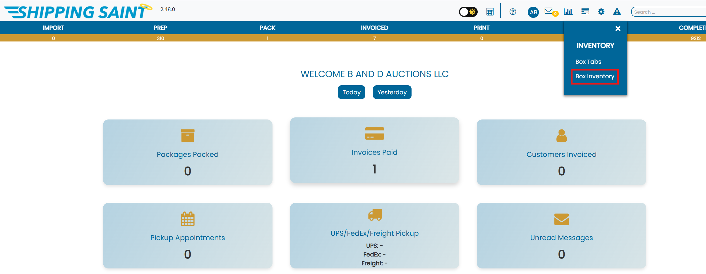
  - Hit the printer icon (green) to update the export, then hit the link icon to download the excel file from ShippingSaint: 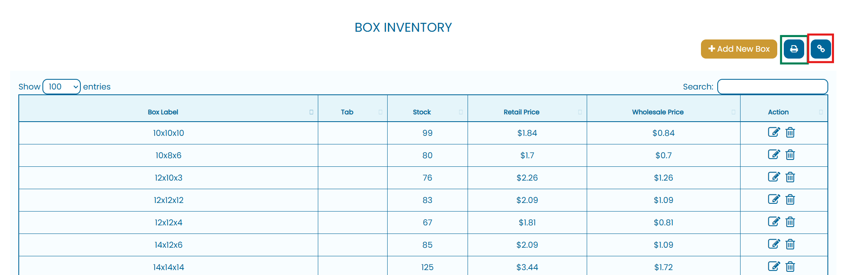

- Open Inventory Analysis Program
  - Go to the ‘Shipping Box Inventory’ folder in the ’Company Files (f:)’ shared drive: 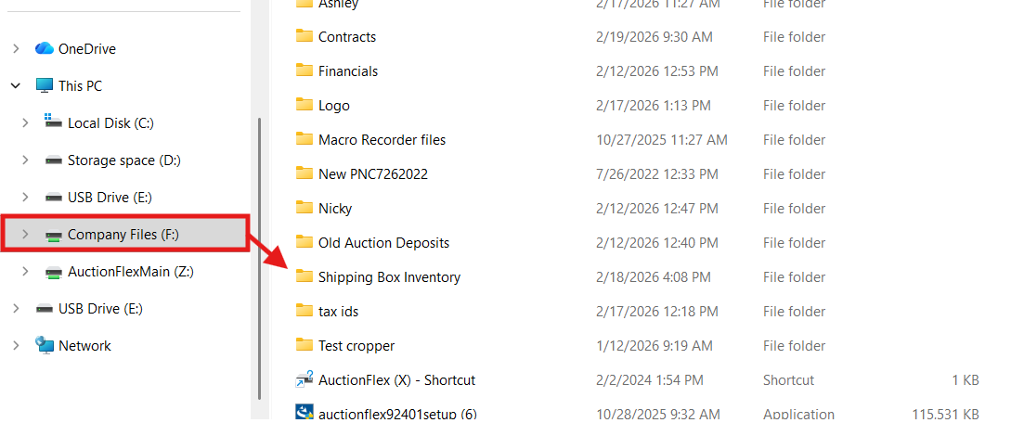
  - Launch the BDBox_Inventory_Manager program with a double-click: 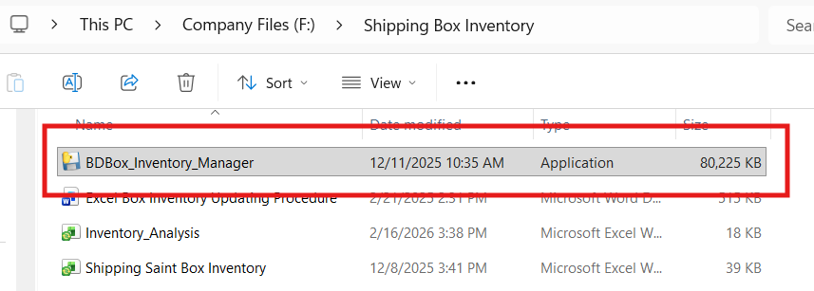
- Click the ‘Browse Excel File’ button in the program to select the excel file which was downloaded from ShippingSaint. Typically named ‘build’ and located in your computers ‘Downloads’ folder: 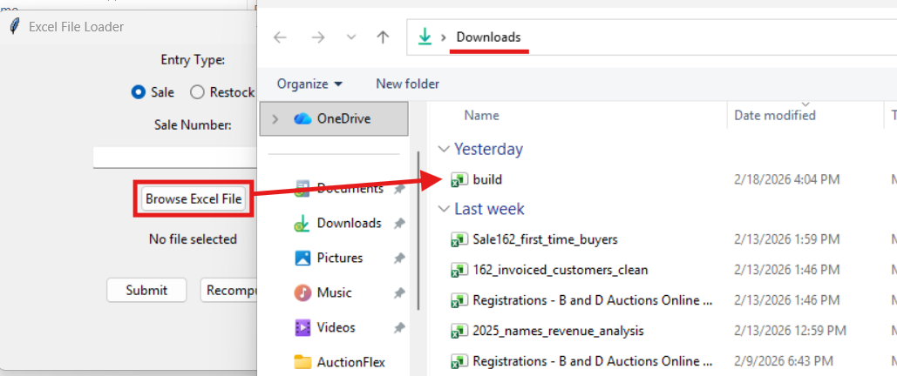
- Enter sale number (reference b) or select the restock check box (reference a), then click ‘Submit’ to process the inventory. NOTE: Do NOT have the ‘Inventory_Analysis’ excel file open when you submit the ShippingSaint Inventory.
  - Check the restock box when you are submitting inventory to be analyzed directly after updating the inventory in ShippingSaint (regardless of reason such as a Uline order or inventory audit).
  - Check the sale box and enter a sale number when submitting the inventory after the conclusion of shipping for a given sale.
- Open the ‘Inventory_Analysis’ excel file to review the updated inventory and projections
  - The Current Inventory & Predictions sheet shows the Current Stock, a quarterly prediction for how much stock is needed for the next 6 sales, and an automatic status
    - The automatically displayed status will show adequate stock for items which have more than the quarterly prediction. Any item which has less current stock than the quarterly prediction, the quantity of items you are short is displayed. Ie., current stock is 20, the prediction is 35, the status will show 15
  - There is also an inventory history sheet available to log the history of the inventory, and the remaining 2 sheets are used to hold sale difference and average use stats.

Helpful Tips:
- When making a Uline order, the number displayed in the status column of the Current Inventory & Predictions sheet is the number of items you want to target in your order.

